Homework 8

Yifu He 190003956

Use the VaR from the previous homework:  
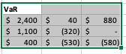

For each portfolio we solve the optimization problem.

In this scenario, eto represents loss term, thus the form is as bellow:

